Migrate Lease Register to SOLA

The guide explains how to migrate lease register database (Access) to SOLA (PostgreSQL) using *Talend Open Studio* as the data integration tool.

# Preparation

Before performing the migration it is essential to prepare the computer that will perform the migration with the necessary software. Talend Open Studio and PostgreSQL with the PostGIS extension.

# Download/Install PostgreSQL

1. Instructions for installing PostgreSQL can be found in the SOLA Development Environment Exercise Guide documentation. Follow those instructions to install a SOLA compatible PostgreSQL instance.

# Download/Install Talend Open Studio (TOS)

1. Download the latest version (v5.2.2) of Talend Open Studion (Data Integration) from <http://www.talend.com/download/data-integration> (approx 480Mb). After download you will get an application file called **"TOS_DI-Win32-r99271-V5.2.2.exe"**
2. Double-click **"TOS_DI-Win32-r99271-V5.2.2"** to run TOS installation setup**.**
3. Select a destination folder for your installation. This folder will contain all your TOS source data.

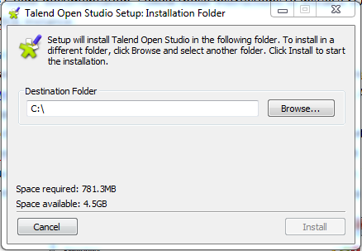

1. Click **Install** and wait for installation to proceed, when completed click **Close**.

# Running the Migration

## Access to PostgreSQL

A project called 'SOLALease' has been created to migrate data from Lease register to SOLA (PostgreSQL). Data in Lease register is stored in an Access application called **lease.mdb**. In order to run this project we will need to import it into TOS.

1. Open **TOS** (Start menu > All Programs > TOS_DI-Win32-r99271-V5.2.2 > TOS_DI-Win32-r99271-V5.2.2)
2. Click **Import...**

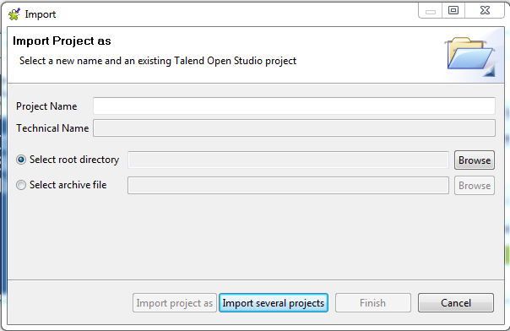

1. Type a name in the **Project Name** field. This is just the imported name for the project.
2. Make sure the **Select root directory** radio button is selected.
3. Click **Browse** button to locate directory where you saved the SOLALEASE project.
4. Click **Finish** to import project. You should get the dialog box below if successfully imported. Your imported project will now appear in the Project list.

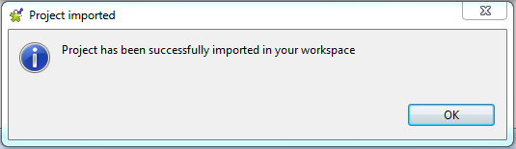

1. **Select** your imported project from the Project list and then **Click Open.**

### 

Note*: If* ***Generation Engine Initialization*** *is processing, wait for it to finish.*

1. **Click "SOLALease 0.1"** under the **Job** category to load SOLALease project. You should be able to view the lease migration job as illustrated below.

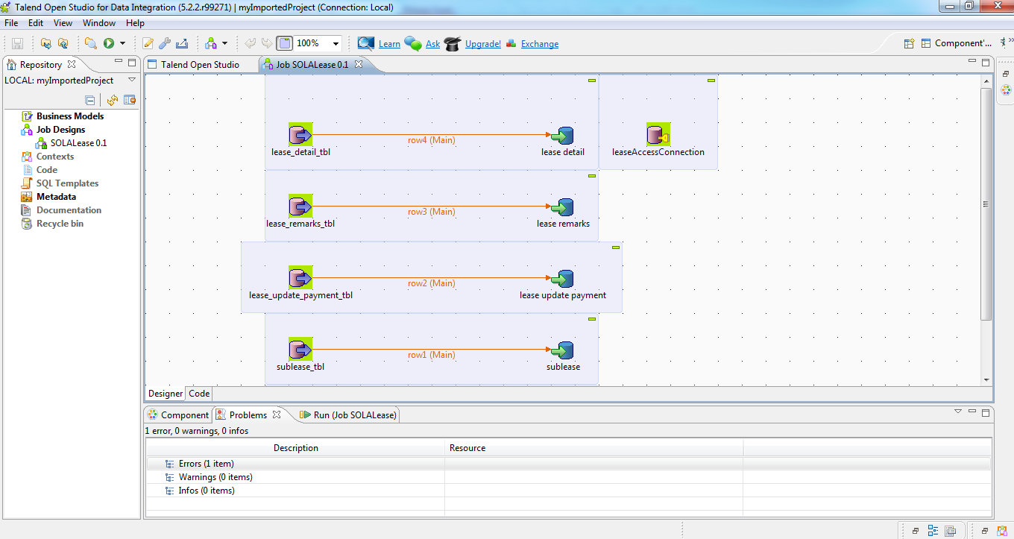

**Note:** *Make sure original database is loaded and storage directory is correct. In case of errors action required to changes component values. //more needed*

1. Click the **Run button** or press **F6** to run the current job.

All data from Lease register (Access) are now migrated into SOLA (PostgreSQL). You can check the output by opening pgAdmin III (Start menu > All Programs > PostgreSQL 9.2 > pgAdmin III).

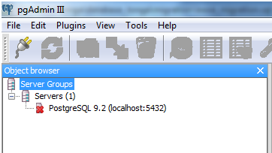

1. Double click **PostgreSQL 9.2 (localhost:5432)**
2. You will be asked for a username and password, if you store your password you won't be asked to input username and password. If prompted, input username as **'postgres'** and password **'S0laT0nga'**.
3. After you have logged in expand **Databases**, three databases will be shown.

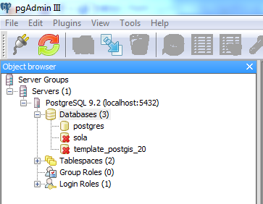

1. Expand **sola**. This is the postgreSQL database that your output migration is stored.

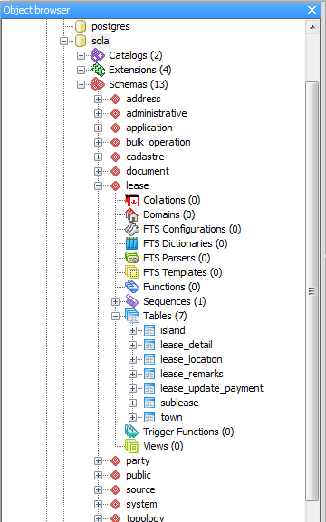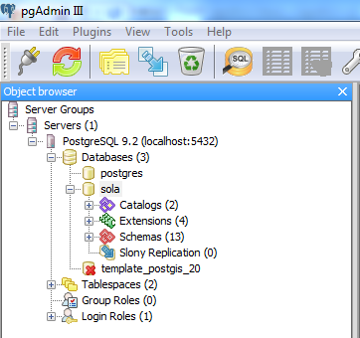

1. Expand Schemas. You will be displayed with SOLA schemas already implemented.
2. Find and expand **lease** schema and expand **Tables**. You will be displayed with the new tables migrated from the lease register. eg. lease_detail, lease_location, etc.
3. If you want to check data in the tables. Right click the table you want to view > View Data > View Top 100 Rows (**View Top 100 Rows** will show the first 100 records if you want to view all the data, choose **View All Rows**)